Exercise 2

# Upload data to ArcGIS Enterprise Using ArcGIS Pro

Open ArcGIS Pro. Ensure the current active portal is ArcGIS Enterprise.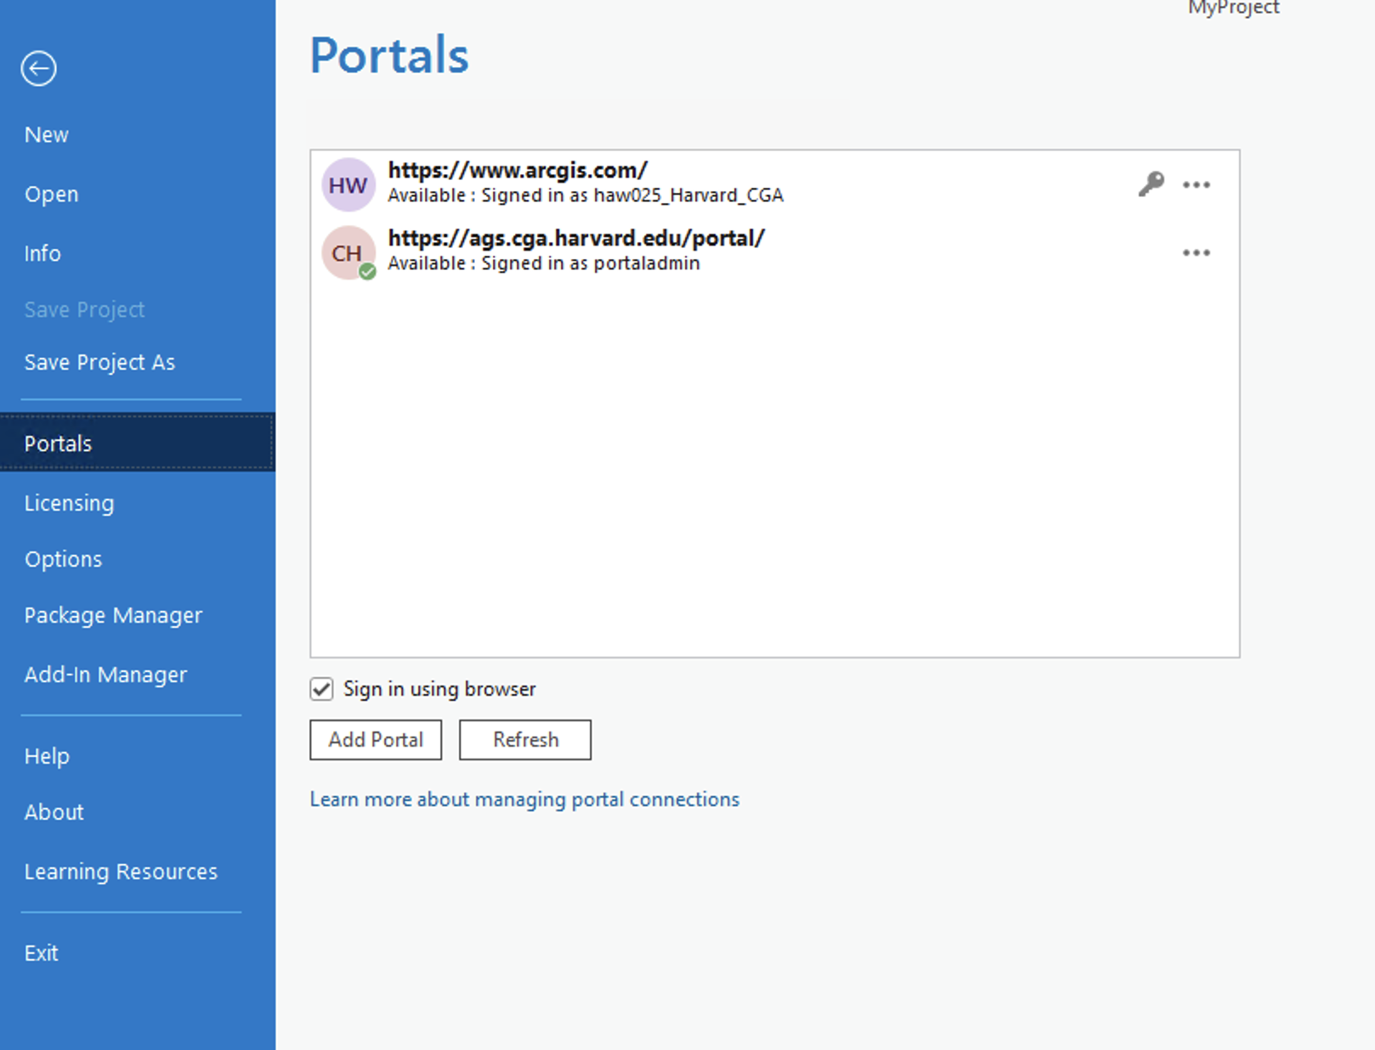

Open the Facility shapefile (<https://github.com/CathyW16/ArcGIS-Enterprise-Workshop/tree/main/data/Facilities> ).

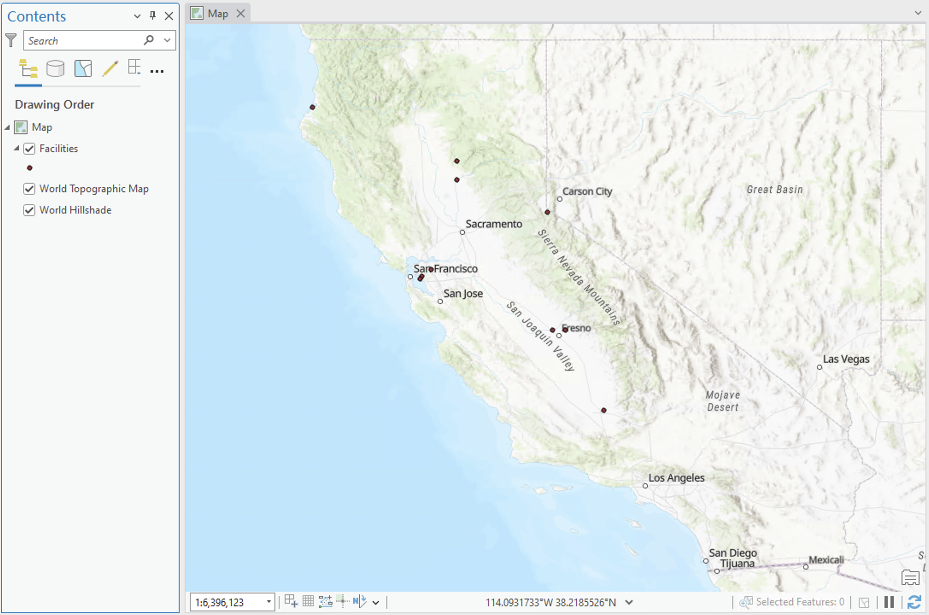

For the data you want to upload to ArcGIS Enterprise, right-click in the Content panel and select Sharing > Share As Web Layer.

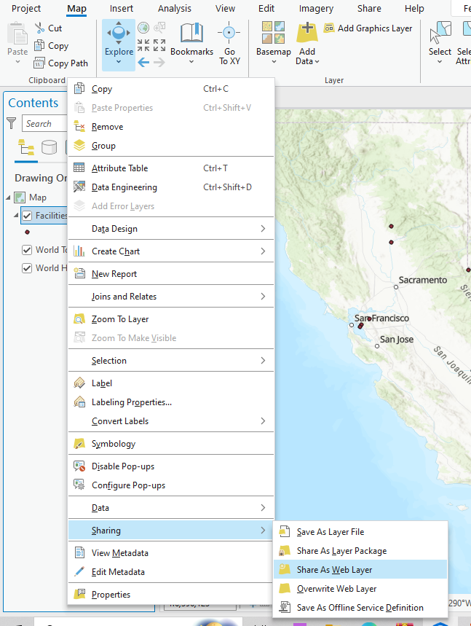

In the 'Share As Web Layer' panel, set the description for the data. To store the data in the cloud without using local storage, choose 'Copy all data'. Since this is point data, select 'Feature'.

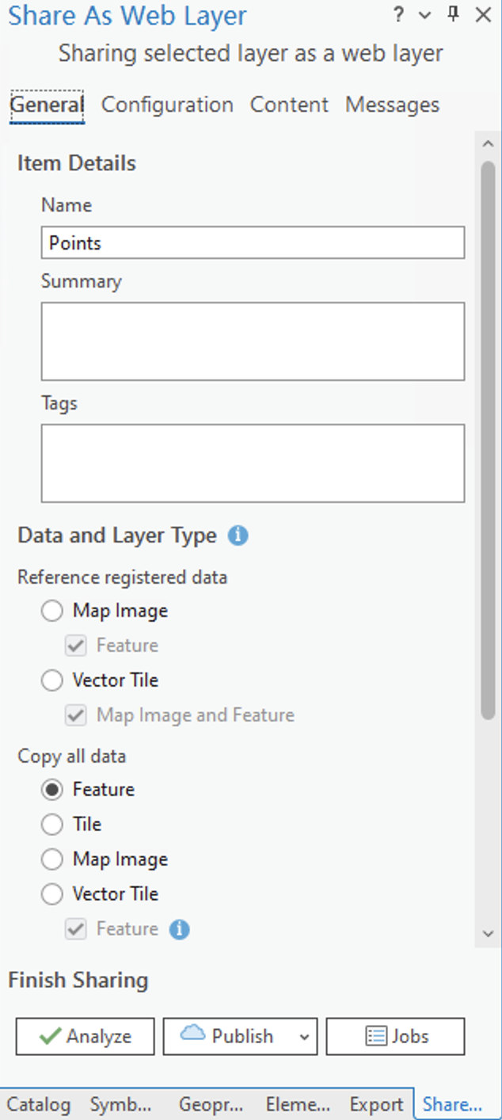

Click 'Analyze'. If an error appears stating 'Unique numeric IDs are not assigned,' click the three-dot icon on the right.

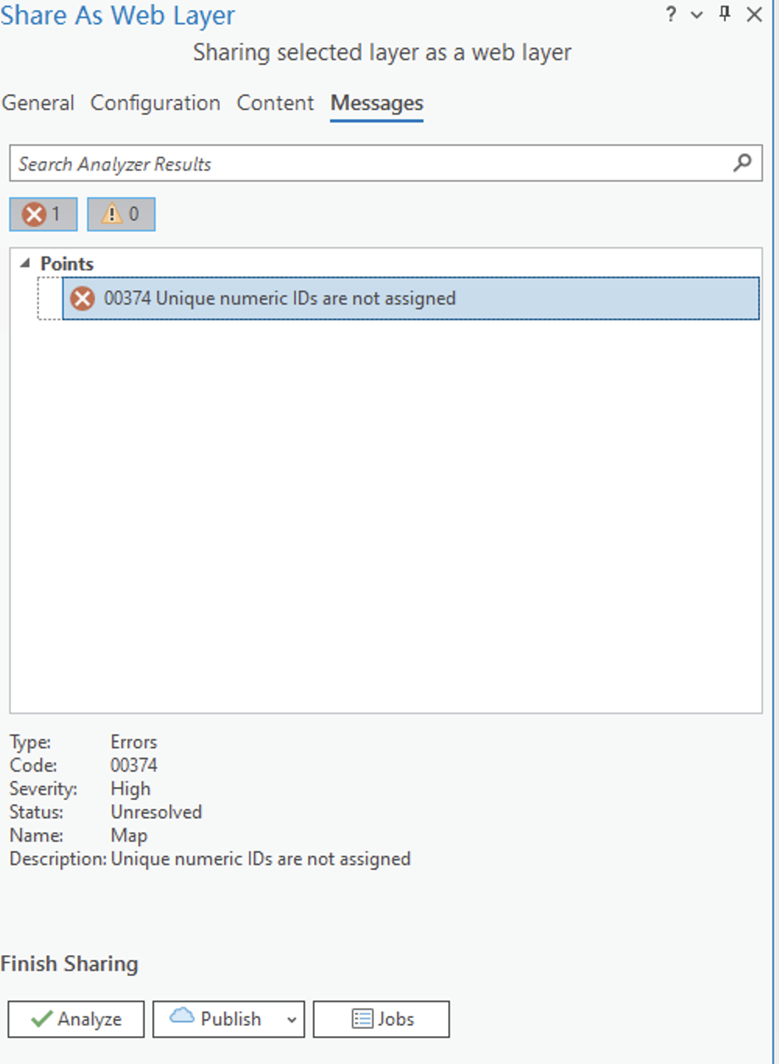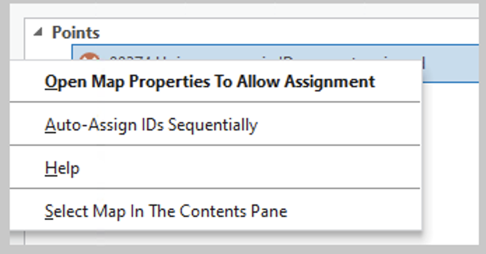

Select 'Auto-assign IDs sequentially'.

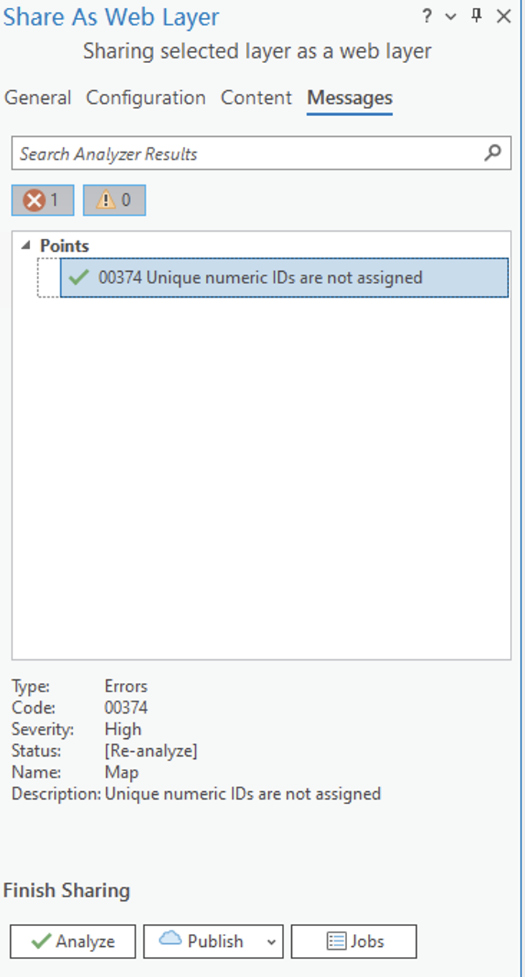

Once the error is resolved, click 'Publish'. After a successful upload, you can see the feature layer under the 'Content' tab in the Portal."

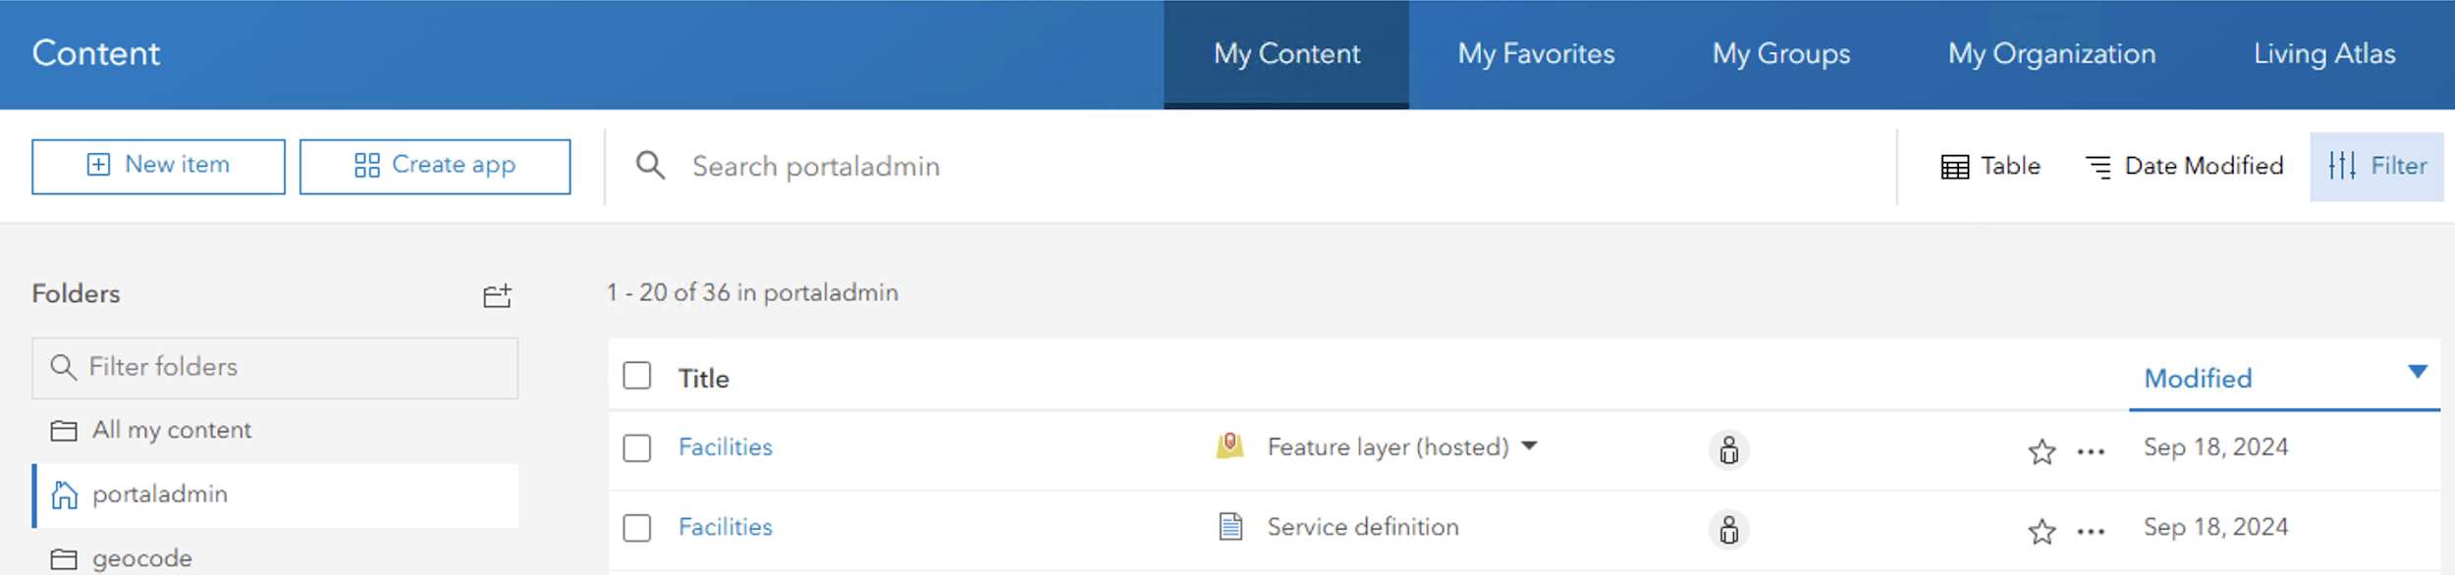

# Analyze data on ArcGIS Pro using ArcGIS Enterprise

Under the 'Analysis' tab, click 'Tools'. In the Geoprocessing panel on the right, click 'Portal'. These tools run remotely on the server.

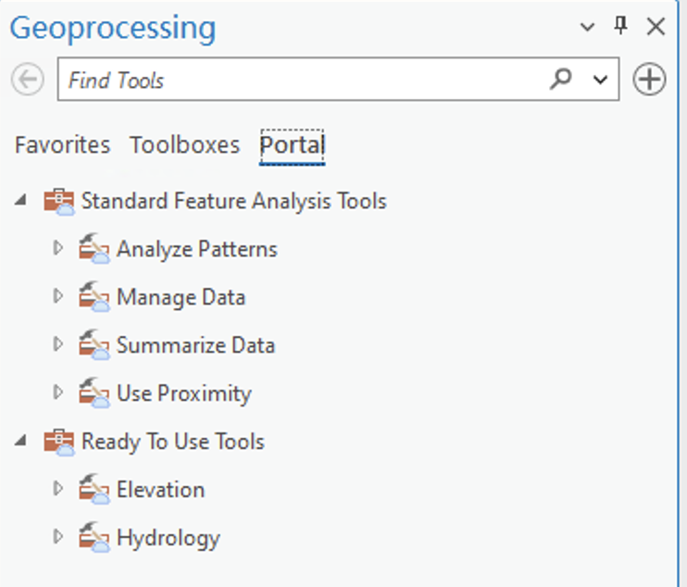

Select 'Create Buffer' under 'Use Proximity'.

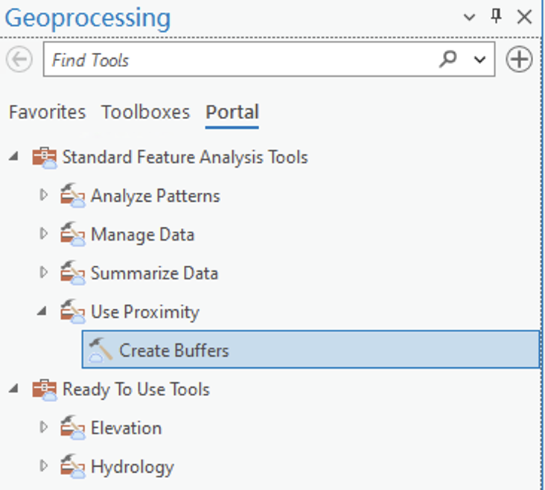

Set the parameters. Please note that after running this tool, the results will be stored in the Enterprise portal, not locally. Click 'Run'.

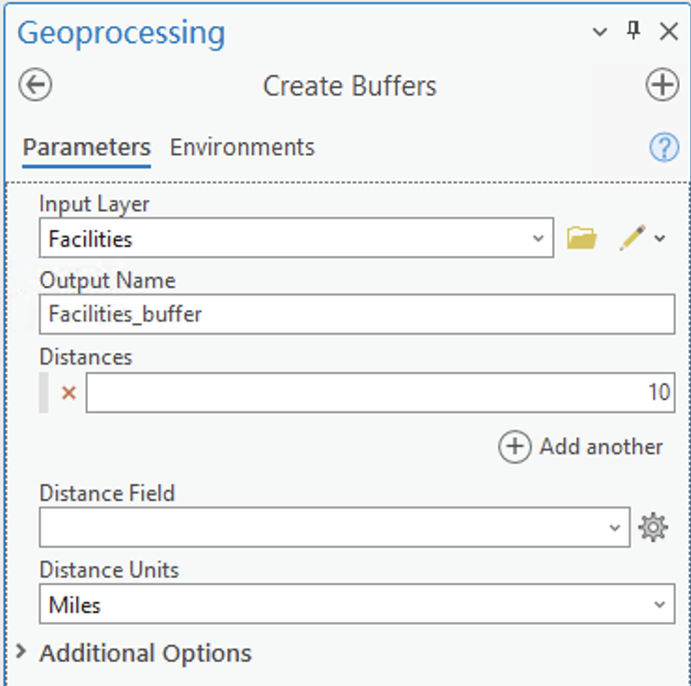

The results will be added to the map and can be viewed in the portal.

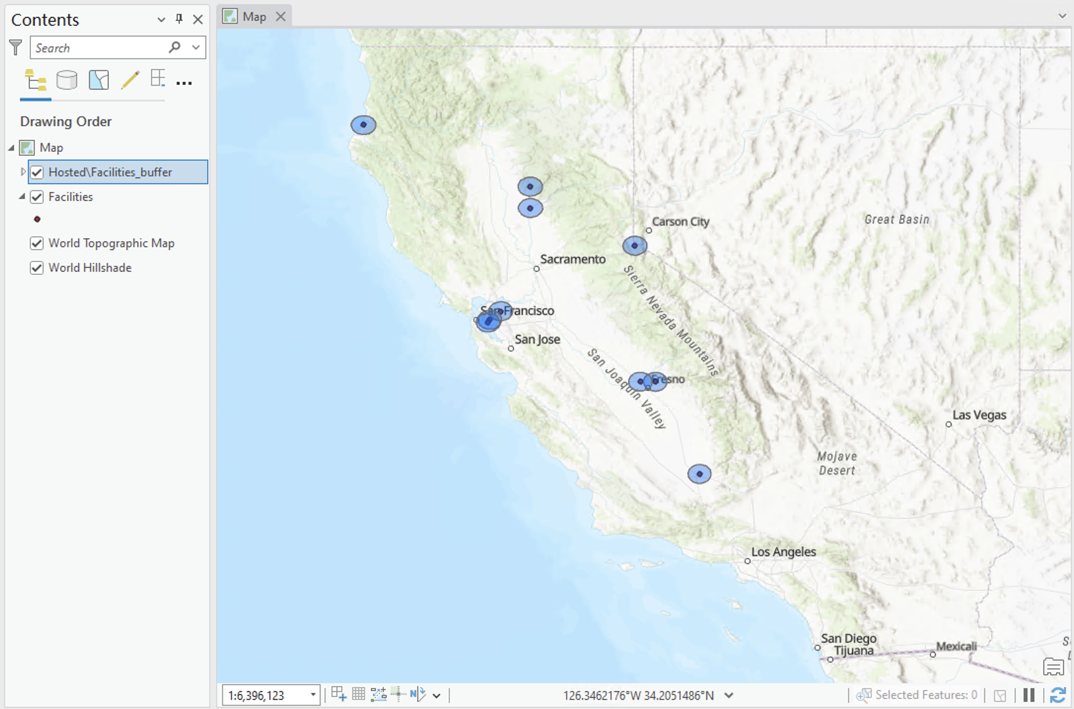

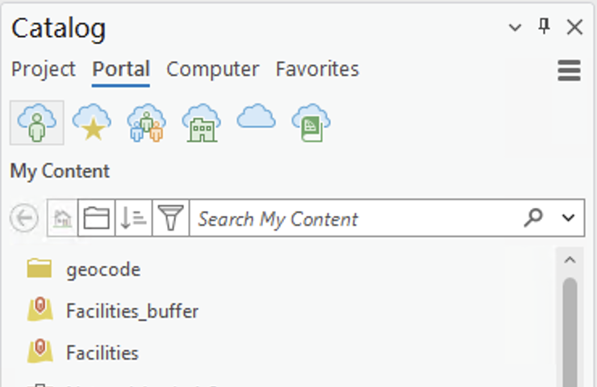

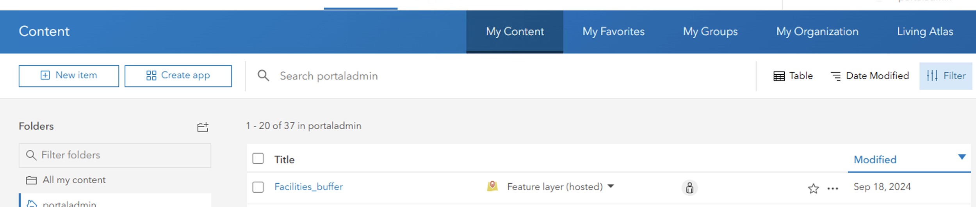

# Visualize data on ArcGIS Enterprise

Under the 'Share' tab, click 'Web Map'. In the panel on the right, enter the name and description, and select 'Copy all data: Visualization'.

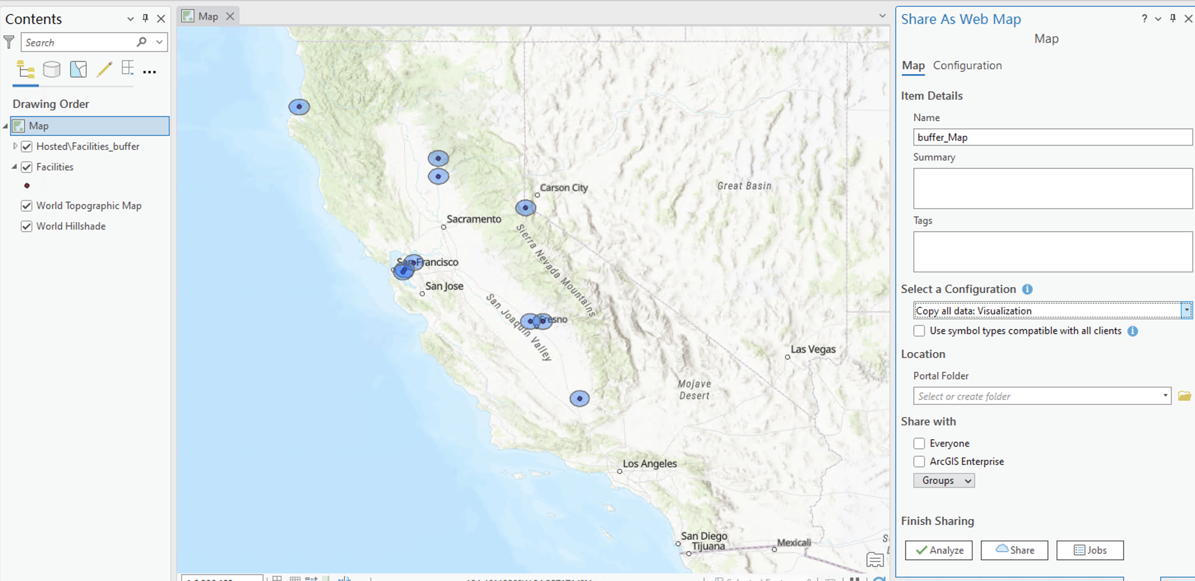

First, click 'Analyze' and then 'Share'.

You can view and open it in 'Content'.

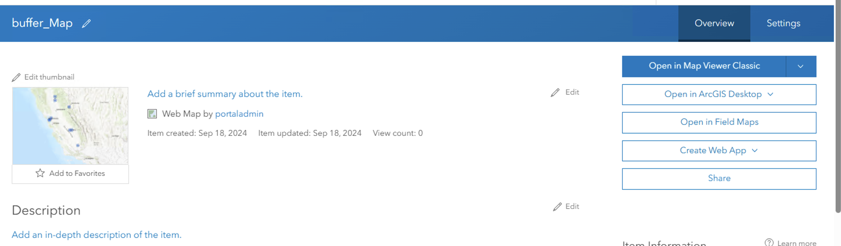

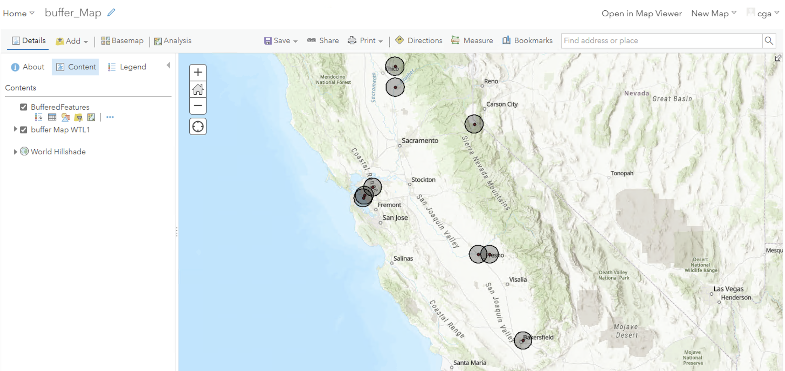

You can click "Share" to share this map using a link.

